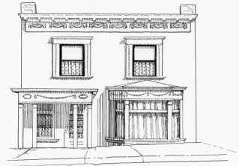 Saturday July 23, 2022
2022 PEARL DeVere Day

Bed Race Rules (Bed check in 10 am Races to start 11 am)

Each team will have three members, 2 “Johns” and one “Pearl”. Pearl will ride on the bed with one John, while the Johns take turns pushing, one “john” will push the bed to the turnaround point, change pushers and return to the start/finish line. It is up to the desecration of the team what their team looks like, it can be three guys or three women if you want, but one will need to be designated as their “Pearl” and stay on the bed for the entire race. There are no set specifications for the bed, just remember you will be pushing it on a Cripple Creek Street, so take in to considerations the weight, ease of handling around corners and durability. Each heat will be timed, the fastest time will be declared the winner of that heat. Number of heats will be determined by the number of entries.

Beds and teams will be judged for their bed design/decorations and the teams for their costumes. Participation in this judging is optional)

Entry Fee is $30 per team. (all team members must be 18 or older) Pre-registration deadline is July 20th. Race day registration opens at 10 am

TEAM NAME_____________________________________________________________

Names of Team members: _______________________________________
________________________________________________________

Contact person____________________________________________________
Phone number: email__________________________________

We wish to participate in Bed judging ________
We will be in costume for the team Judging__________

Checks need payable to the Old Homestead House Museum. (PO Box 268 Cripple Creek, CO 80813 or drop it off at museum during regular business hours)

Registration and payment method will be up on line soon.

See back of this form for waiver statement

Waiver: In consideration of Old Homestead House Museum accepting this entry (application) form, we, the undersigned, intending to be legally bound, hereby, for myself, my family, my heirs, my executors and my administrators, forever waive, release, and discharge any and all rights and claims or suits, known or unknown, that I or they have or may have against the organizers of this event, the city of Cripple Creek, and all race officials, volunteers and sponsors of the race for any and all injuries suffered by me

Signature 1st team member Date

Signature 2nd Team member Date

_____________________________________________________________________________________
Signature 3rd Team member Date

